**Assignment 5 – Stereo Reconstruction**

In this assignment we implemented the algorithm for stereo reconstruction given the two images.

**Part 1: SIFT Matching**

In this part of the assignment, we calculated correspondence between two images using SIFT, KNN. We also applied constraints of ratio test (0.75) and two-way correspondence test.

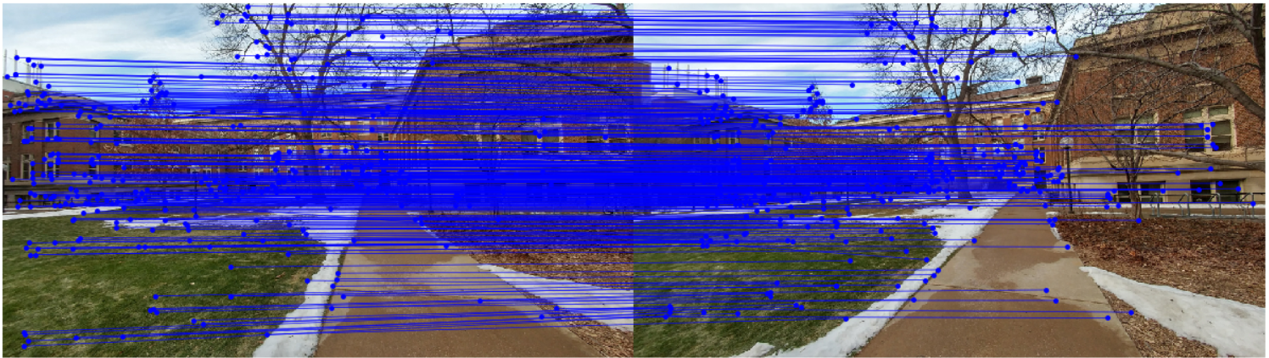

Correspondences

**Part 2: Fundamental Matrix**

In this part, we computed fundamental matrix F with the 8 point algorithm and RANSAC – threshold 0.01, iterations 10000.

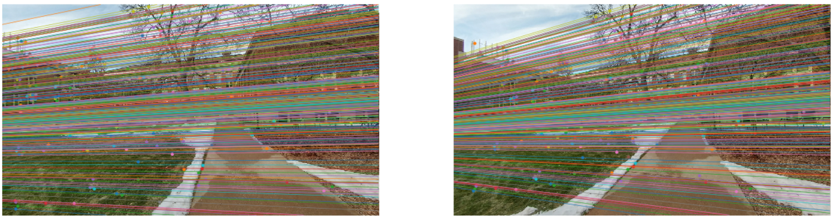

Epipolar lines

**Part 3: Triangulation and Disambiguate pose**

In this, we triangulated the 2D coordinates to 3D, using two camera projection matrices. Then from all possible camera compositions we find the best one using chirality test.

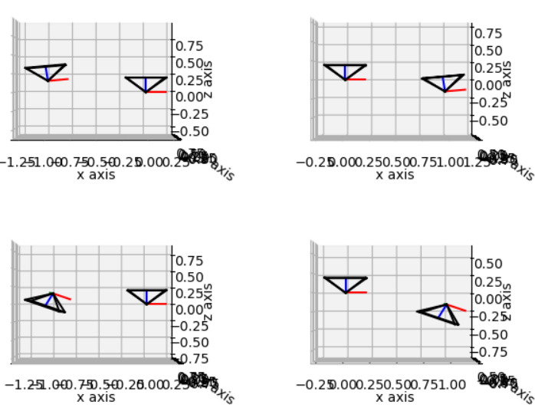 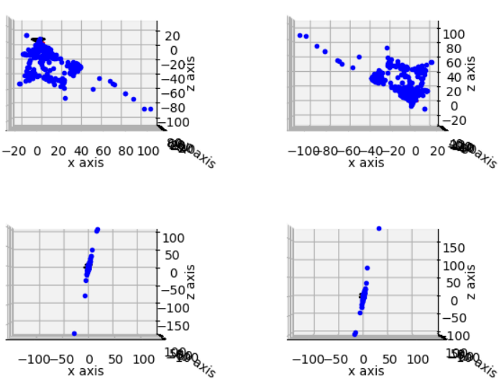

|  |  |
| --- | --- |
| Camera composition | #Inliers |
| 1 | 8 |
| 2 | 371 |
| 3 | 88 |
| 4 | 291 |

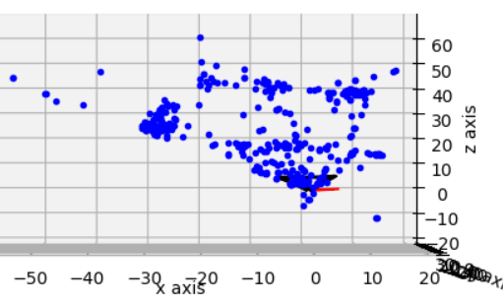

**Part 4: Dense match**

In this, we implemented the algorithm to compute disparity given two stereo images. These images are formed after rectifying those with calculated homographies. For dense match SIFT descriptors were used.

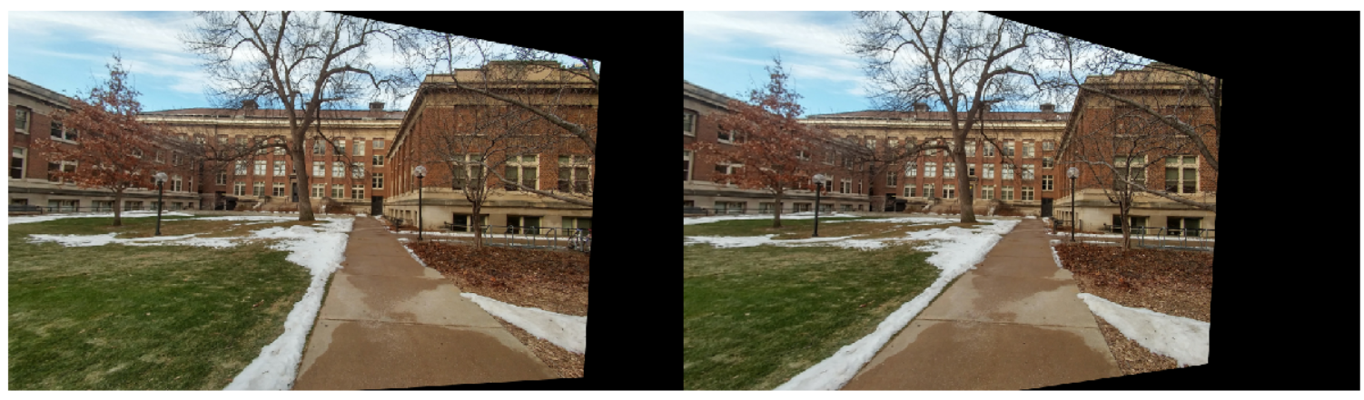

Rectified stereo images

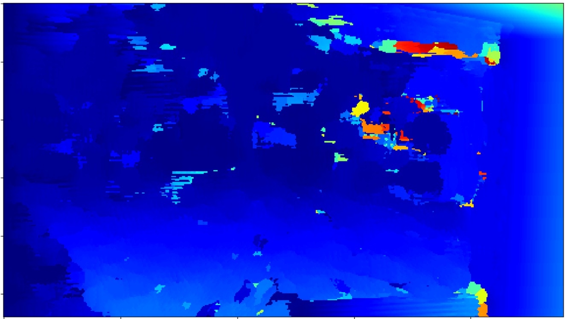

Unnormalized Disparity map